IT Support Ticket Analysis Using Power BI

1. Project Title:
IT Support Ticket Analysis Using Power BI

2. Introduction:

Description:
- IT Support Analytics is the process of analyzing IT service tickets to understand issue trends, SLA performance, and support team efficiency.

- This project aims to analyze IT support tickets using Power BI and provide insights to improve IT service operations.

3. Business Problem Statement:
The organization is facing challenges in IT support operations and wants to understand:
- How many IT tickets are generated?
- Which issues occur frequently?
- Are SLA targets being met?
- Which agents perform better?
- Which departments raise more tickets?
- Where delays happen in ticket resolution?

4.Objectives of the Project:

Main Objectives:
- Calculate total, resolved, and open tickets
- Analyze ticket trends over time
- Identify SLA breached tickets
- Evaluate agent performance
- Analyze tickets by category and department
- Build interactive dashboards
- Provide business recommendations

5.Tools & Technologies Used:

Tool | Purpose
Power BI | Data visualization & dashboard
Power query | Data cleaning & transformation
DAX | KPI calculations
Excel/CSV | Dataset

6. Dataset Description:
Source: IT_Support_Tickets_Dataset.csv
Dataset Size:
- Total Records: 300 tickets
- Columns: 12+

7.Data Preprocessing Steps

7.1 Data Loading:
- Imported dataset into Power BI using CSV file.
- Home → Get Data → Excel workbook → Load
Dataset Preview Before Loading:
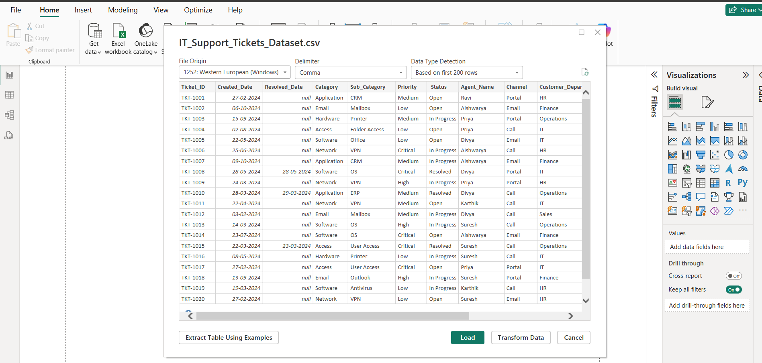

Before Data cleaning:
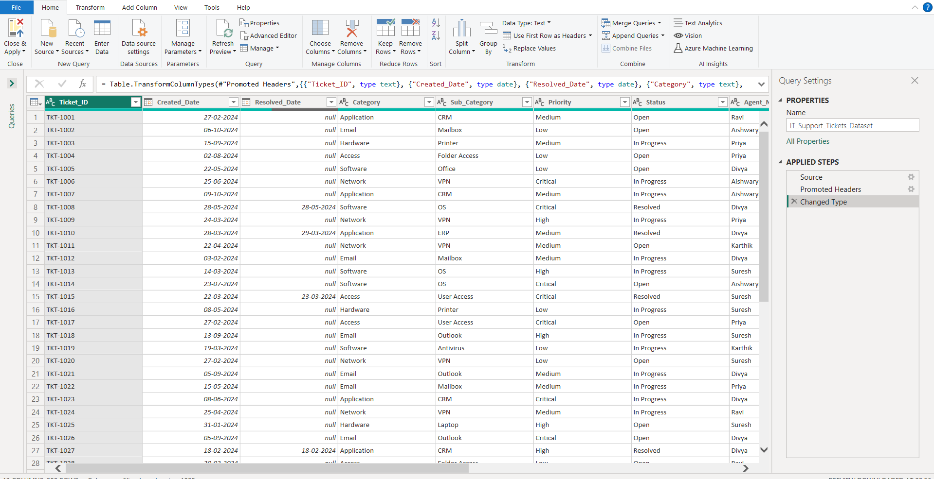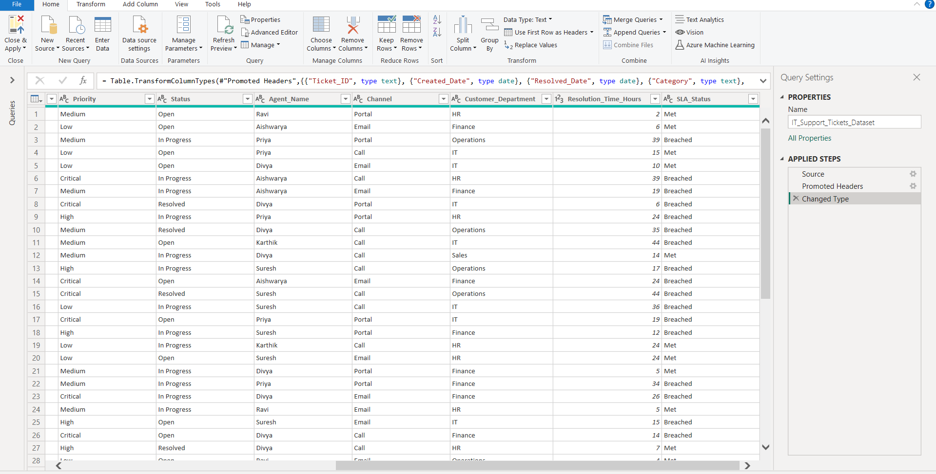

7.2: Data Cleaning and Transformation:

The dataset was transformed using Power Query Editor to clean, standardize, and prepare the data for analysis.

7.2.1 Open Power Query Editor
Action:
Transform Data → Power Query Editor
The Power Query Editor was used to perform data cleaning and transformation operations.

7.2.2 Create SLA Flag Column
A new column called SLA_Flag was created to convert SLA_Status into numeric format.
Logic:
If SLA_Status = "Met" → 1
Else → 0
This column helps in calculating SLA-related KPIs using DAX.

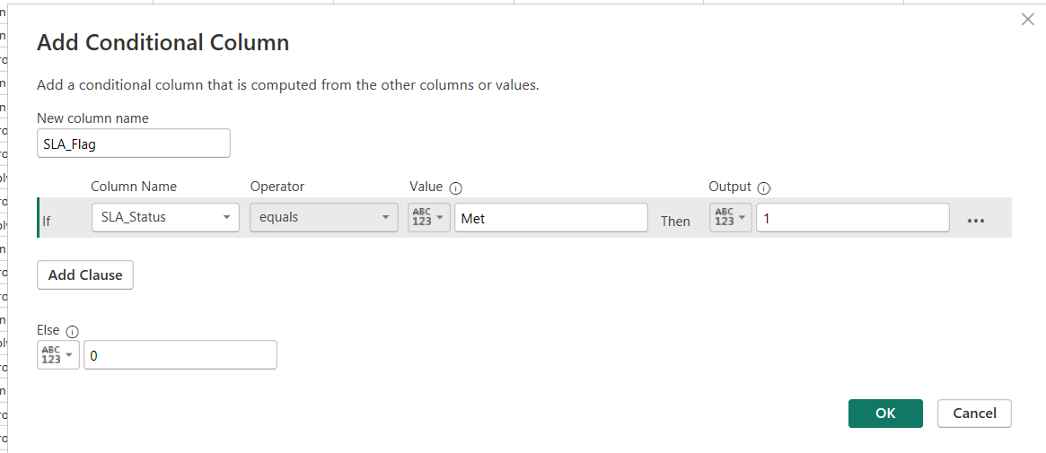

7.2.2 Create Resolved Flag Column
A new column called Resolved_Flag was created to identify resolved tickets.
Logic:
If Status = "Resolved" → 1
Else → 0
This column helps in calculating resolution metrics.

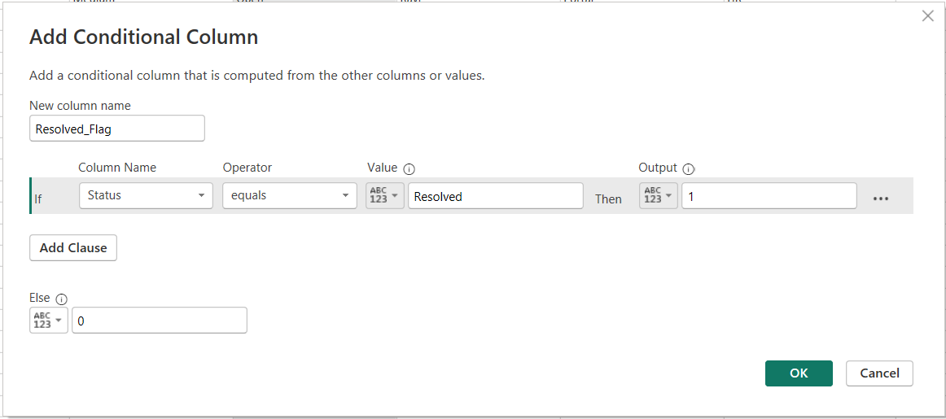

7.2.3 Create Resolution Time Group Column
A new column called Resolution_Time_Group was created to categorize tickets based on resolution time.
Logic:
If Resolution_Time_Hours <= 5 → "Fast Resolution"
If Resolution_Time_Hours <= 15 → "Medium Resolution"
Else → "Delayed Resolution"
This grouping helps in identifying delayed tickets and analyzing support efficiency.
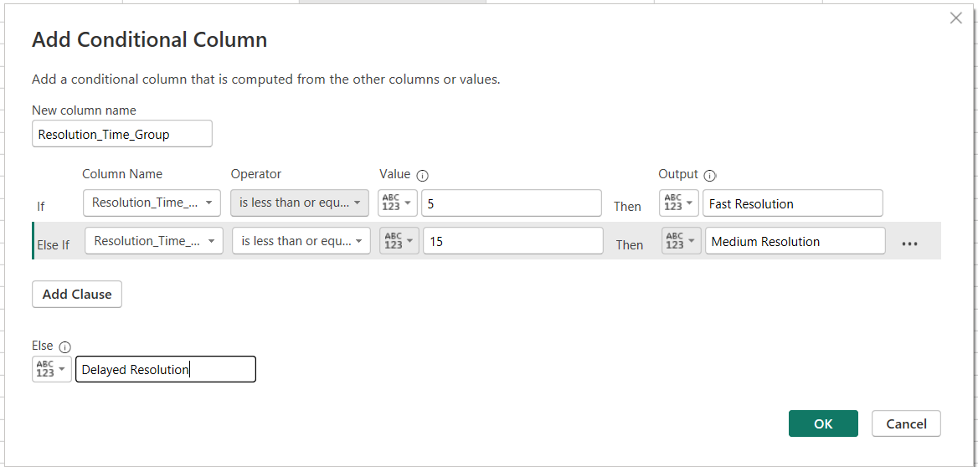

7.2.4 Change Data Types
Data types of important columns were changed to ensure accurate calculations and analysis.
The following conversions were performed:
- Created_Date → Date
- Resolved_Date → Date
- Resolution_Time_Hours → Whole Number
- SLA_Flag → Whole Number
- Resolved_Flag → Whole Number
This step ensures consistency and reliability in data analysis.

7.3 Data Modeling:

Data Modeling (Star Schema):

A star schema data model was designed to improve data organization and performance.
A dimension table called Dim_Agent was created to store unique agent information.

Fact Table:
Fact_Tickets [ Main table]

Dimension Tables:
Dim_Date
Dim_Agent
Dim_Category
Dim_Department
Dim_Priority
Create Dim_Agent Table:
A dimension table called Dim_Agent was created to store unique agent information.
Dim_Agent =
DISTINCT(
SELECTCOLUMNS(
Fact_Tickets,
"Agent_Name", Fact_Tickets[Agent_Name]
)
)

Create Dim_Category Table
A dimension table called Dim_Category was created to store unique issue categories and sub-categories.
This table helps in analyzing ticket distribution by issue type.
Dim_Category =
DISTINCT(
SELECTCOLUMNS(
Fact_Tickets,
"Category", Fact_Tickets[Category],
"Sub_Category", Fact_Tickets[Sub_Category]
)
)

Create Dim_Department Table:
A dimension table called Dim_Department was created to store unique customer departments.
This table helps in analyzing tickets raised by different departments.

Dim_Department =
DISTINCT(
SELECTCOLUMNS(
Fact_Tickets,
"Department", Fact_Tickets[Customer_Department]
)
)

Create Dim_Date Table
A dimension table called Dim_Date was created using the Created_Date column to enable time-based analysis.
Additional columns like Year, Month, Month Number, and Quarter were added for trend analysis.
Dim_Date =
ADDCOLUMNS(
CALENDAR(MIN(Fact_Tickets[Created_Date]), MAX(Fact_Tickets[Created_Date])),
"Year", YEAR([Date]),
"Month", FORMAT([Date], "MMM"),
"Month Number", MONTH([Date]),
"Quarter", "Q" & FORMAT([Date], "Q")
)
Create Relationships:
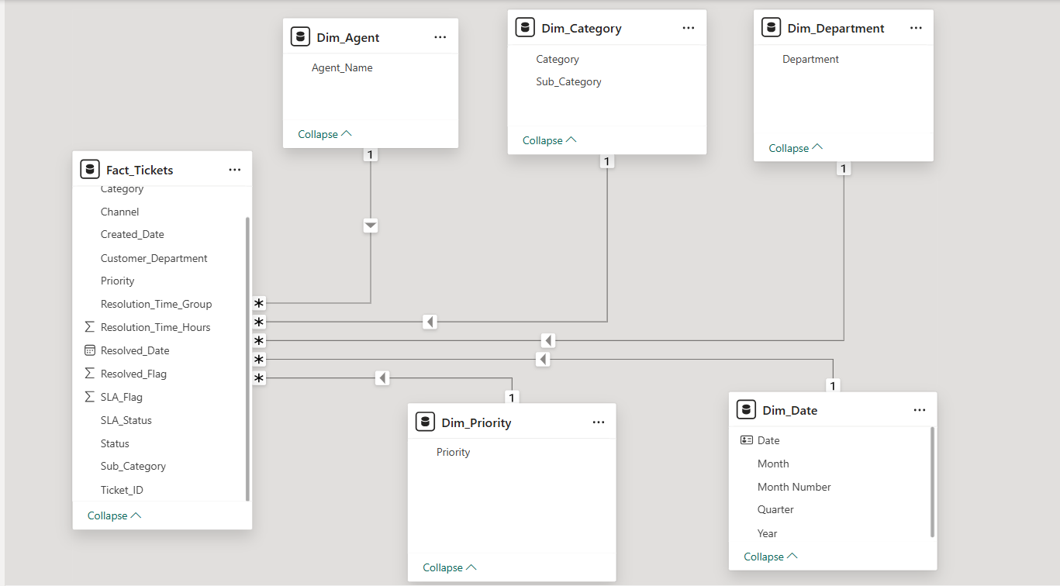

7.4 DAX MEASURES:
Power BI → Modeling → New Measure.
The following DAX measures were created to calculate key performance indicators (KPIs) for IT support operations:

7.4.1 Total Tickets:
Total Tickets = COUNT(Fact_Tickets[Ticket_ID])

7.4.2 Resolved Tickets
Resolved Tickets =
CALCULATE(
COUNT(Fact_Tickets[Ticket_ID]),
Fact_Tickets[Status] = "Resolved"
)

7.4.3 Open Tickets
Open Tickets =
CALCULATE(
COUNT(Fact_Tickets[Ticket_ID]),
Fact_Tickets[Status] = "Open"
)

7.4.4 In Progress Tickets
In Progress Tickets =
CALCULATE(
COUNT(Fact_Tickets[Ticket_ID]),
Fact_Tickets[Status] = "In Progress"
)

7.4.5 SLA Met Tickets
SLA Met Tickets =
CALCULATE(
COUNT(Fact_Tickets[Ticket_ID]),
Fact_Tickets[SLA_Status] = "Met"
)

7.4.6 SLA Breached Tickets
SLA Breached Tickets =
CALCULATE(
COUNT(Fact_Tickets[Ticket_ID]),
Fact_Tickets[SLA_Status] = "Breached"
)

7.4.7 SLA %
SLA % =
DIVIDE([SLA Met Tickets], [Total Tickets])

7.4.8 Avg Resolution Time
Avg Resolution Time =
AVERAGE(Fact_Tickets[Resolution_Time_Hours])
Advanced DAX Measures :
7.4.9 Resolution Rate %
Resolution Rate % =
DIVIDE([Resolved Tickets], [Total Tickets])

7.4.10 Backlog Tickets (Pending Tickets)
Backlog Tickets =
[Open Tickets] + [In Progress Tickets]

7.4.11 High Priority Tickets
High Priority Tickets =
CALCULATE(
COUNT(Fact_Tickets[Ticket_ID]),
Fact_Tickets[Priority] = "High"
)

7.4.12 Critical Priority Tickets
Critical Priority Tickets =
CALCULATE(
COUNT(Fact_Tickets[Ticket_ID]),
Fact_Tickets[Priority] = "Critical"
)

7.4.13 Agent Productivity (Tickets per Agent)
Tickets per Agent =
DIVIDE([Total Tickets], DISTINCTCOUNT(Fact_Tickets[Agent_Name]))

7.4.14 Top Agent Ranking
Agent Rank =
RANKX(
ALL(Dim_Agent[Agent_Name]),
[Resolved Tickets],
,
DESC
)

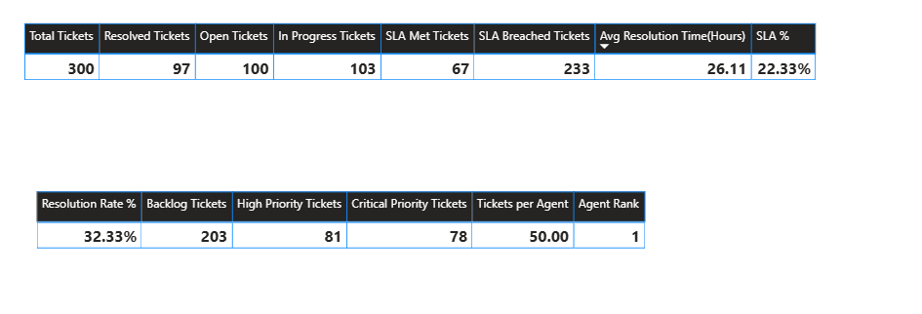
KPI Insights
- Only 32% of tickets are resolved, indicating backlog issues.
- 77% of tickets breached SLA.
- High and Critical priority tickets contribute significantly to workload.
- Average resolution time is high (26 hours), indicating process inefficiency.

8.Dashboard Design and Publishing Power BI service :
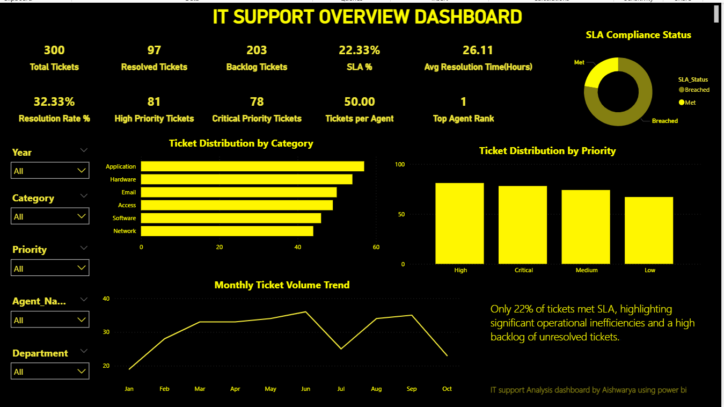

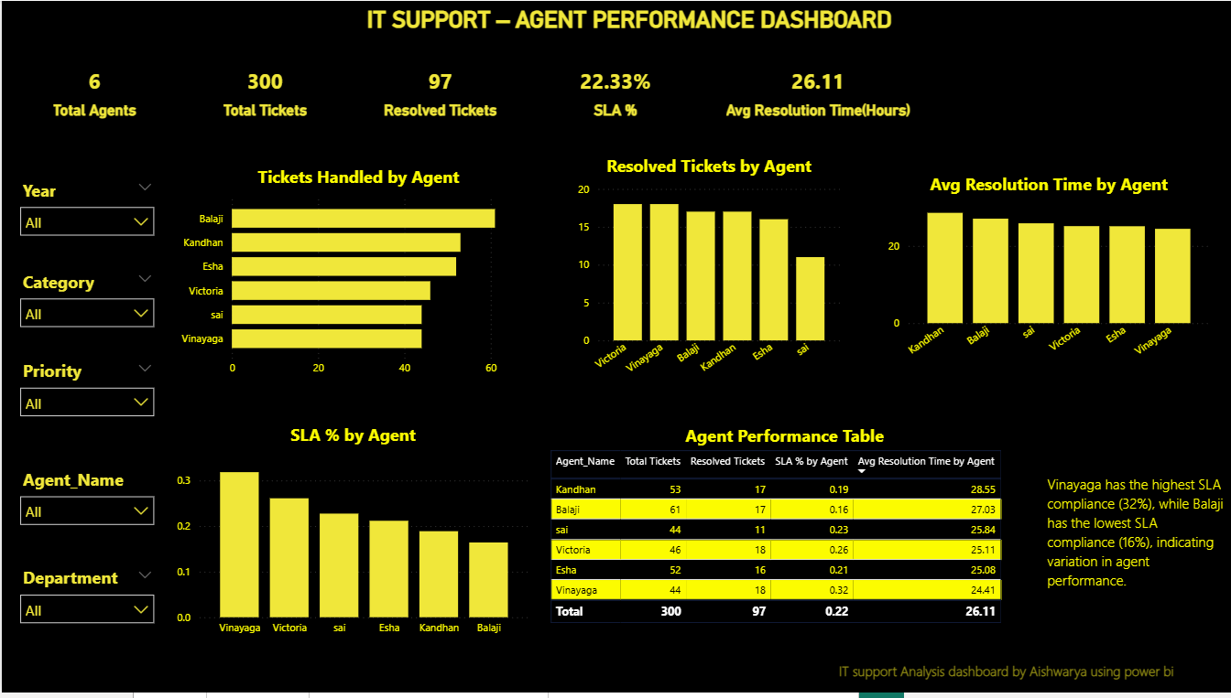
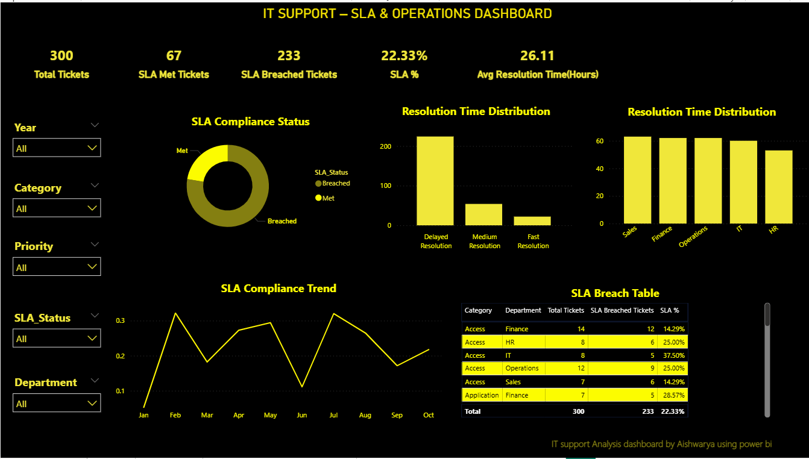

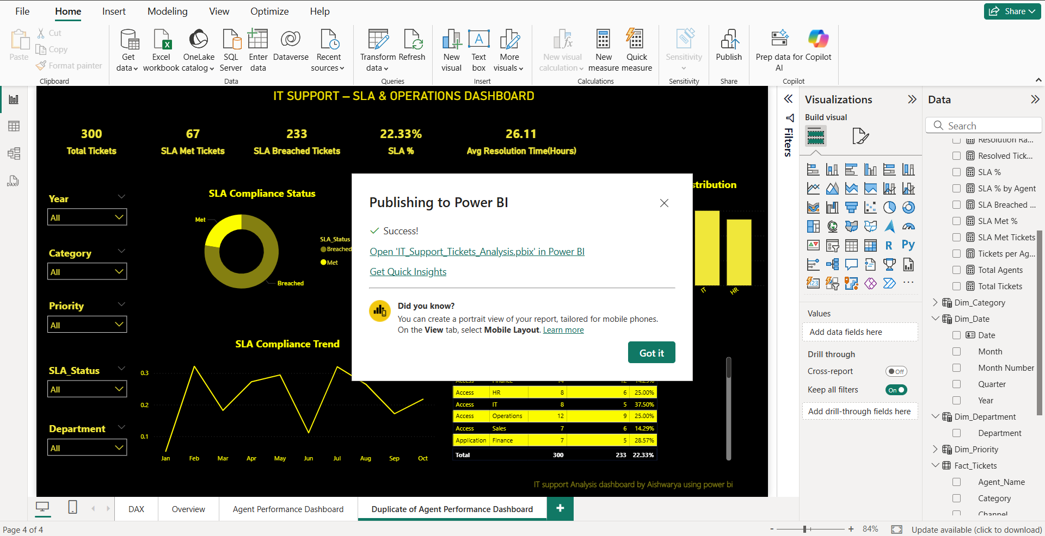

9.Business Insights:
- SLA compliance is low (22%), indicating operational inefficiencies.
- Backlog tickets are significantly higher than resolved tickets.
- High and Critical priority tickets contribute heavily to workload.
- Agent performance varies significantly across agents.
- Certain departments generate more tickets, indicating process gaps.
- Average resolution time is high, suggesting the need for process optimization.

10.Conclusion:
This project demonstrates how Power BI can be used to analyze IT support operations, monitor SLA performance, and evaluate agent productivity.
By leveraging data modeling, DAX measures, and interactive dashboards, the analysis provides actionable insights to improve IT service efficiency and decision-making.

